Section 1: Case Summary

Scenario Title: | Subarachnoid Hemorrhage
Keywords: | SAH, hydrocephalus, airway management, neurosurgical emergency
Brief Description of Case: | A previously healthy 46y F is transferred from a surrounding hospital with CT-confirmed diagnosis of SAH with hydrocephalus. Five days ago, she had a severe headache and today presented to the referring hospital with confusion. The patient is transferred direct to Neurosurgery and booked for OR but experiences progressive decreases in her GCS while awaiting surgery. She is admitted to ICU by the junior resident who attempts management and calls for the fellow. When the ICU fellow arrives, the patient’s GCS is 5 and she then becomes hypotensive and desats. The ICU team must secure the airway, manage the blood pressure, and coordinate care with Neurosurgery.

Goals and Objectives
Educational Goal: | Solidify approach to worsening clinical status following SAH
Medical Objectives: | - Manage the airway of a patient with SAH and declining clinical status  - Consider possible causes of decreased LOC following SAH  - Use appropriate interventions to manage blood pressure in a patient with SAH and unsecured aneurysm
CRM Objectives: | - Use closed-loop communication and task delegation to effectively lead a team caring for a patient with a neurosurgical emergency  - Convey management priorities with team to achieve a shared mental model  - Provide constructive feedback to a Jr. trainee  - Effectively communicate changes in patient condition to consultants
EPAs Assessed: | Core EPAs: C1 Resuscitating and coordinating care for critically ill patients  C3 Providing airway management and ventilation

Learners, Setting and Personnel
Target Learners: | ☐ Junior Learners |  | ☒ Senior Learners |  |  | ☐ Staff
 | ☐ Physicians | ☐ Nurses |  | ☐ RTs | ☐ Inter-professional
Location: | ☒ Sim Lab |  | ☐ In Situ |  |  | ☐ Other:
Recommended Number of Facilitators: | Instructors: 1
 | Sim Actors: 1 RN, 1 Jr ICU resident, 1 Neurosurgery resident; with option to add 1 RT
 | Sim Techs: 1

Scenario Development
Date of Development: | November 14, 2017
Scenario Developer(s): | Dr. D. Piquette
Affiliations/Institutions(s): | University of Toronto
Last Revision Date: | April 2022
Edited By: | Dr. Ailish Valeriano & Dr. Sameer Sharif
Contact E-mail: | ailish.valeriano@medportal.ca; sameer.sharif@medportal.ca
Version Number: | 2

Section 2A: Initial Patient Information

- Patient Chart
Patient Name: Lucy Kleinberg |  |  |  | Age: 46 | Gender: F | Weight: 60 kg
Presenting complaint: Headache with confusion
Temp: 37.4 C | HR: 110 bpm | BP:170/95 |  | RR: 12/min | O₂Sat: 92% | FiO₂: 4L/min NP
Cap glucose: 7 |  |  |  | GCS: 5 (E1V1M3)
ED Triage note:
CTAS 1 – Direct transfer to Neurosurgery from surrounding hospital for SAH. Pt had severe headache 5 days initially treated by GP as migraine. Has new confusion today, according to husband. Initial GCS noted as 14 prior to transfer. “SAH with hydrocephalus” on CT head at referral hospital (images on CD). No trauma hx. Declining neuro status with transfer - GCS 11 on arrival (E3V3M5)

Allergies: None
Past Medical History:  Asthma  Migraines (remote)  Anxiety/depression |  |  | Current Medications:  Sertraline  Ventolin

Section 2B: Extra Patient Information

A. Further History
ICU resident or nurse can provide the following history to the fellow when the case starts:

This 46y F patient had an acute, severe headache while walking her dog 5 days ago. She had no loss of consciousness or neck pain and her family doctor prescribed NSAIDS and antiemetics for migraine.
The headache diminished but did not disappear over the 5 last days.
Today her husband notes she had some confusion - not remembering the day of the week - so she was brought to the referring ED where a diagnosis of SAH with hydrocephalus was made on CT. GCS at referral hospital was 14 (E4V4M6). No history of seizure activity, trauma, or substance use.
She was transferred to this hospital for neurosurgical management and GCS was 11 (E3V3M5) on arrival. Neurosurgery has seen and assessed, and patient is awaiting OR for External Ventricular Drain (EVD) placement. Neurosurgery team is currently in the OR with another case.
The Jr ICU resident was called to admit the patient, at which time her GCS was 6 (E1V1M4) with BP 180/95.
The resident gave 500cc of Mannitol and 20mgIV hydralazine 30 mins ago and called the fellow.

If requested, can provide the neurosurgery consult note and initial bloodwork. Head CT images are on a CD and are not available at this time.
B. Physical Exam
Cardio: Normal S1/S2 no murmurs  ECG monitors show SR at 110bpm with 3mm diffuse STE | Neuro: pupils 3mm symmetrical and sluggish but reactive;  GCS 5: eyes remain closed/no verbal response/flexing x4
Resp: airway patent, normal BS bilat | Head & Neck: No signs of head injury
Abdo: soft, non-distended, non-tender | MSK/skin: cap refill <sec, skin warm and dry
Other: Patient is lying flat on stretcher. There is a foley catheter with 1L clear urine in bag

Section 3: Technical Requirements/Room Vision

A. Patient
☒ Mannequin (Adult)
☐ Standardized Patient
☐ Task Trainer
☐ Hybrid
B. Special Equipment Required
EKG leads/wires
NIBP Cuff
Pulse oximeter
Capnography
IV Bags/Lines
Arterial line kit
Foley catheter
Intubation supplies/Airway cart
Ventilator
C. Required Medications
Saline
Vasopressors
Induction agents
D. Moulage
None

E. Monitors at Case Onset
☒ Patient on monitor with vitals displayed and ECG leads on
F. Patient Reactions and Exam
Airway: NP in place at 4L/min
Breathing: Spontaneous regular breath sounds bilaterally
Circulation: pulse regular, normal cardiac sounds, warm and dry to touch
Disability: Pt is obtunded, GCS 5 (E1,V1,M3)
Eyes closed, Pupils 3mm, symmetric, reactive
No verbal response when spoken to/painful stimuli
Responds to pain stimulus by flexing x 4 limbs
Exposure: Temp 37.4*C, pt is in gown lying flat on stretcher

Section 4: Sim Actor and Standardized Patients

Sim Actor and Standardized Patient Roles and Scripts
Role | Description of role, expected behavior, and key moments to intervene/prompt learners. Include any script required (including conveying patient information if patient is unable)
Nurse | You are a skilful and experienced ED nurse taking care of this patient. Her GCS was 11 (E3V3M5) on arrival one hour ago when Neurosurgery came to assess her.  The ICU resident was then called to admit the patient to the ICU. When the ICU resident assessed the patient, the GCS was 6 (E1V1M4) with BP 180/95. The resident asked you to give 500cc of Mannitol (you mentioned that it was a lot, but the resident confirmed that they wanted that dose) and hydralazine 20mg IV before calling the ICU fellow.  You assist the ICU team with the care of Mrs. Kleinberg.  You may suggest a transfer to the ICU prior to further treatment such as intubation.
Neurosurgery resident | About an hour ago, the patient arrived at this hospital and was assessed by you. The GCS was then 11 (E3V3M5). You reviewed the imaging provided by the referring hospital (Report: extensive subarachnoid hemorrhage largely centered craniocervical junction and basal cisterns, with early extension into the ventricles. Secondary moderately advanced hydrocephalus). The patient is waiting to go to the OR for the insertion of an external ventricular drain (EVD) as your team is with another patient in the OR.  After you left the ER, the ICU resident was called to admit the patient to the ICU.  You will be called back about a change in the patient condition.
Jr ICU resident | You were called by ER to admit the patient to the ICU. When you assessed the patient 30min ago, the GCS was 6 (E1V1M4) with BP 180/95. You asked the RN to give 500cc of Mannitol and hydralazine 20mg IV before calling the ICU fellow who is coming to assess the patient.  You have limited experience with neurosurgery patients.  Once the patient is stabilized, you ask the fellow for some feedback about your initial management.

Section 5: Scenario Progression

Scenario States, Modifiers and Triggers
Patient State/Vitals | Patient Status | Learner Actions, Modifiers & Triggers to Move to Next State |  | Facilitator Notes
1. Baseline State  Rhythm: SR with precordial deep TWI  HR: 110bpm  BP: 170/95  RR: 12  O₂SAT: 92% on 4L/min NP  T: 37.4 ºC  GCS: 5 (E1V1M3) | The patient is lying flat on the stretcher with eyes closed | Expected Learner Actions  ☐ Ensure IV access and consider arterial line for BP monitoring  ☐ Raise head of bed  ☐ Target SBP < 160mmHg (Labetalol 10-20mg IV; Hydralazine 10-20mg IV; Enalapril 2.5-5mg IV)  ☐ Make decision to take control of airway  ☐ Consider transfer of patient to ICU for further management  ☐ Contact neurosurgery about the changes in the patient’s neurologic status | Modifiers  Triggers  -Decision to manage the airway or 4 mins elapsing  -Decision to treat hypertension or 5 mins elapsing
2. Hypotensive (over first 5 mins)  Rhythm: SR with precordial deep TWI  HR: 100bpm  BP: 80/50  RR: 12  O₂SAT: 92% on 4L/min NP  T: 37.4 ºC  GCS: 5 (E1V1M3) | BP progressively drops to 80/50 over first 5 mins unless intervention | Expected Learner Actions  ☐ IV fluid bolus  ☐ IV phenylephrine push  ☐ IV vasopressor infusion | Modifiers  -Increase sBP by 10 over 3 min for fluid bolus  -Increase sBP by 10 over 1 min for phenylephrine  -Stabilize BP over 2 min for IV vasopressor infusion  Triggers  -Decision to manage the airway or 5 mins elapsing | Adjust BP according to choice of drugs
3. Desat (at 5 mins)  Rhythm: SR with precordial deep TWI  HR: 110bpm  BP: variable depending on learner action  RR: 12  O₂SAT: 87% on 4L/min NP  T: 37.4 ºC  GCS: 5 (E1V1M3) | O₂SAT decreases to 87% if not intubated or BMV by 5 mins | Expected Learner Actions  ☐ NRB mask  ☐ BMV  ☐ Oral airway  ☐ Neuroprotective RSI  ☐ Contact neurosurgery about the changes in the patient’s condition (mention the WFNS Grade) | Modifiers  -Increase sat to 88% if NRB applied or FiO2 increased  -Increase sat to 92% if BMV  -Increase sat to 97% if oral airway  -Increase sat to 99% postintubation  Triggers  - Post-intubation, progress to next-state | May prompt ETI
4. Post-Intubation Management  HR: 120bpm  BP: 165/90  RR: 16  O₂SAT: 98% on PCV  T: 37.4 ºC  GCS: 3 (E1V1M1) | Patient intubated with GCS 2T | Expected Learner Actions  ☐ Target SBP < 160  ☐ Post-intubation Sedation  ☐ Nimodipine (30-60mg) via OG Tube if BP can tolerate  ☐ ± Repeat CT in consultation with NSx  ☐ Maintain HOB up  ☐ Consider Target Na > 145  ☐ Provide feedback to ICU resident (mention high dose of Mannitol given; discuss why they didn’t listen to ER RNs concerns about the dose of mannitol being too high) | Modifiers  Triggers  -If 2 minutes have elapsed, prompt ICU Fellow to provide feedback to the resident  - End case after feedback to the Resident has been provided | If 1 minute has elapsed in this phase, RN to trigger ICU Fellow by asking about BP targets and whether there is a medication we can administer

Appendix A: Laboratory Results

CBC
WBC 8.8
Hgb 132
Plt 282

Lytes
Na 142
K 3.6
Cl 103
Cr 44
Glucose 7

Extended Lytes
Ca 2.17
Mg 0.94
PO₄ 1.43
Albumin 37

VBG
pH 7.36
pCO₂ 41
pO₂ 33
HCO₃ 24
Lactate 1

Appendix B: ECGs, X-rays, Ultrasounds and Pictures

Neurosurgery Consult note:
Patient name: | Lucy Kleinberg | PROGRESS NOTES

[One hour ago] | NEUROSURGERY CONSULTATION  46yo, transfer for SAH/hydrocephalus  Severe headache 5 days ago. Saw her family doctor, who prescribed treatment for a migraine. Patient continued to complain of headache at home, and developed confusion earlier today. She was brought by her husband to the ER of the referring hospital. Her GCS was then reportedly 14 (E4V4M6).  CT report: extensive subarachnoid hemorrhage largely centered craniocervical junction and basal cisterns, with early extension into the ventricles  E/O:  GCS: 11 (E3V3M5)  Pupils equal, reactive  No asymmetry – motor exam.  SAH with acute hydrocephalus  PLAN  - Admit to ICU  - EVD when OR available  - CTA  - BP target less than 160

Appendix C: Facilitator Cheat Sheet & Debriefing Tips

Medical Debriefs:

What are the indications for a definitive airway in a patient with SAH and unsecured aneurysm?
- Securing the airway is an important step in the stabilization of a patient with declining level of consciousness and SAH. Indications for definitive airway include inability to protect airway, poor oxygenation or ventilation.

What is the target PaCO2 for a patient with increased ICP?
- Target normocapnia and avoid significant hyper- or hypoventilation.

Consider possible causes of declining LOC following SAH
- The differential can include increased ICP and hydrocephalus, re-bleed, post-ictal, sedation, vasospasm (starts on day 3 and generally ends at day 21) and delayed cerebral ischemia

What are the priorities in BP management in SAH?
- In the case of high grade SAH with hydrocephalus and deteriorating mental status, the goal is to maintain adequate cerebral perfusion pressure. CPP= MAP-ICP
- There is no conclusive evidence on appropriate BP range for SAH but target systolic BP <160mmHg is often used (AHA Guidelines). If a patient is awake and alert, a target SBP < 140mmHg is reasonable to decrease the risk of re-rupture if the aneurysm has not been coiled yet.
- If the patient becomes hypotensive (as in this case) there is a risk of ischemia and infarct carrying high neurological morbidity. Attempt to maintain MAP >65mmHg with titratable vasopressor infusion.

How to grade SAH severity?
- Two main grading scales are the World Federation of Neurological Surgeons Scale (WFNS) and the Hunt and Hess Scale; WFNS is what is used presently (see below)

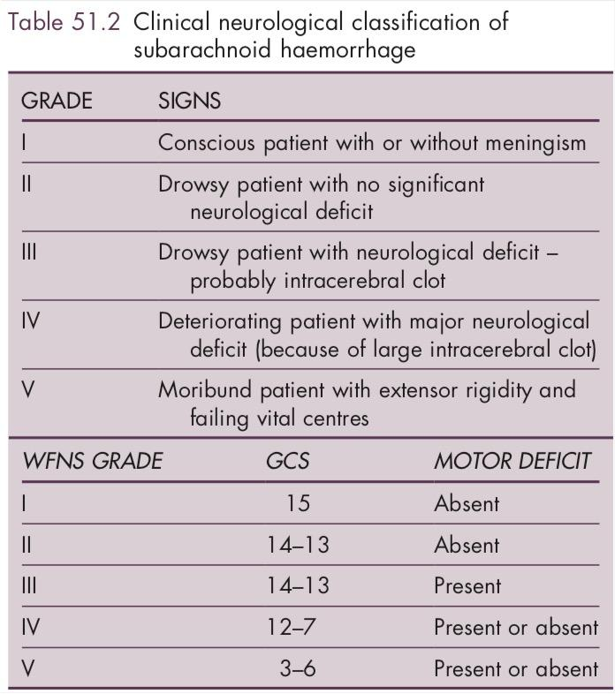

Dosing of Mannitol, HTS, Nimodipine
- Mannitol 0.5g/kg (can cause hypotension)
- 3% Saline 3cc/kg
- Nimodipine 60mg ORALLY (can give 30mg if BP soft) 🡪 Prevents vasospasm

What are the complications of SAH?
- Rebleeding: May occur in first few hours after admission. Incidence is 9-17% with most causes occurring within 6 hours.
- Acute Hydrocephalus may occur within first 24 hours
- Delayed Cerebral Ischemia occurs in up to 70% of patients
- Parenchymal Hematoma occurs in up to 30% of patients and has a much worse prognosis than SAH alone
- Medical complications occur in 40% of SAH patient (see below)
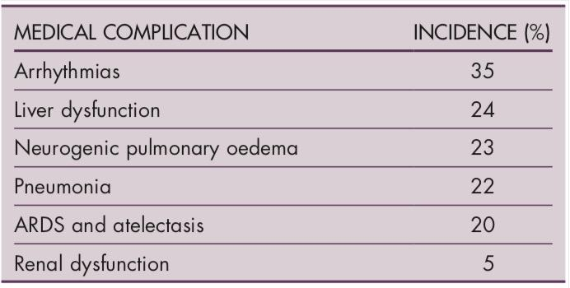

What is the Fischer Classification of SAH on CT
Fisher Classification for CT Appearance of SAH: (? indicate risk of vasospasm)
Grade 1 – No blood
Grade 2 – Diffuse, thin <1mm SAH with no clots
Grade 3 – Local Clots or layers of blood >1mm in thickness
Grade 4 – Intracerebral or intraventricular blood (+/- SAH)

What is Triple H Therapy for SAH
Triple H Therapy: Hypervolemia / Hemodilution / Hypertension

At first sign of clinical vasospasm:
- Hypervolemic hemodilution goal hematocrit 33-38%
- CVP 10-12 mmHg (PAWP 15-18mmHg)
- SBP 160-200mmHg in clipped aneurysms
- Cohort compared to literature standards

Neuroprotective RSI
- Be mindful of the following: (i) exaggerated reflex sympathetic response to laryngoscopy; (ii) hypotension due to induction agents; and (iii) exacerbation of raised ICP

CRM Debriefs:
- How did the team handle this case?
- Do you feel that the critical nature of the patient’s presentation was adequately understood by all team members?
- Were there any gaps in communication?
- How effective was the content, delivery and reception of feedback given to the junior resident?

References

- Chung DY, Abdalkader M, Nguyen TN. Aneurysmal subarachnoid hemorrhage. Neurologic clinics. 2021 May 1;39(2):419-42.
- Diringer MN. Management of aneurysmal subarachnoid hemorrhage. Critical care medicine. 2009 Feb;37(2):432.
- Marcolini E, Hine J. Approach to the diagnosis and management of subarachnoid hemorrhage. Western Journal of Emergency Medicine. 2019 Mar;20(2):203.
- Stringer, R, Ogilvy C, Rordorf G. Aneurysmal subarachnoid hemorrhage: Treatment and prognosis. In: UpToDate, Post TW (Ed), UpToDate, Waltham, MA. (Accessed on April 27, 2022).
- Riley B, de Beer T: 51 - Acute cerebrovascular complications. In: Oh's Intensive Care Manual (Seventh Edition). Edited by Bersten AD, Soni N: Butterworth-Heinemann; 2014: 568-579.e562.

